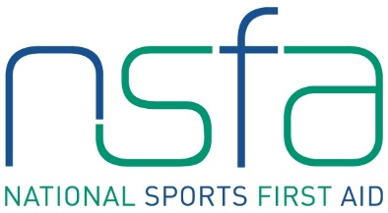

Sports First Aid Registration Form

ONLINE COMPONENT

Course Date & Venue: TBC
BLOCK CAPITALS PLEASE

Name
(Including title)
Address

Post Code
Contact Numbers | Home:  Business:  Mobile:
E-mail Address
Date of Birth
Occupation
Sport

Position
e.g. coach, player

Level
e.g. club, national

Club Name

Previous First Aid Knowledge

** Please note we will contact you as we are able for completing the practical aspect of the course **

In administering this course, we shall process your personal data in accordance with our Privacy Notice, a copy of which can be found on our website www.hampdensportsclinic.com/contact or you can request a paper copy by emailing nsfa@hampdensportsclinic.com

We would like to send you marketing emails from time to time with information about our special offers and promotions, please tick here if you do not want to receive such emails. 

£100.00 course fee can be paid by either of the following payment types:
- Bank Transfer - Sort Code: 80-83-33; Account No: 00801736; Ref: NSFA followed by your name 
- Credit/Debit Card - please call Kirsty McDonald on 0141-616 6164 to make payment 
Please tick your desired payment type.

Please return completed form to:
Kirsty McDonald, NSFA Administrator, Hampden Sports Clinic, Hampden Park, Glasgow, G42 9ED
or by email to: nsfa@hampdensportsclinic.com

Signature Date

